3D Printer Material Prediction Using Watson Auto AI

**Index:**

1. INTRODUCTION

* Overview
* Purpose

1. LITERATURE SURVEY

* Existing Problem
* Proposed Solution

1. THEORITICAL ANALYSIS

* Block diagram
* Hardware/Software designing

1. EXPERIMENTAL INVESTIGATIONS
2. FLOWCHART
3. RESULT
4. ADVANTAGES/DISADVANTAGES
5. APPLICATIONS
6. CONCLUSION
7. FUTURE SCOPE
8. BIBLOGRAPHY

APPENDIX

1. Source code
   1. **INTRODUCTION**

* **Overview:**

                 I had done my internship on machine learning with python in this internship I have learned what is the use of machine learning  and what are its applications ML is the sub topic of AI and the internship is based on how we can study ML with python.

python programming the basics of the course about python functions,exceptional handling and OOPS concept.

ML uses the approch with the help of algorithms and staticstic to make future decisions or predictions to slove a problem in ml inputs are called as features and outputs are called as labels.ML is mainly used for building a model where data and the output are given to the system or algorithm and model is generated.By implementing 5 steps ML model can be made collection of data,data wrangling where we can filter the data,Analyze the data,train and test the algorithm,deployment testing the data with web applications.

* **purpose:**

**problem:** predicting 3D printer material using machine learning

**solution:** This model is to predict the best material to be used for building 3D models

* 1. **LITERATURE SURVAY:**

* **Existing problem:**

                      3D printing materials, usually called by their traditional names such as ABS, nylon and more are available in the majority, but you have to be aware that many of the 3D printing materials only mimic true thermoplastics. Choosing the right material allows you to improve the shape, quality and function of your 3d printed part. Hence, selection of the correct 3D printing material is highly essential. To identify the type of material required after a 3D model is designed is a complicated task.The aim of the study is to determine the best material which will be perfect for the given use case. Where there are eleven setting parameters and one output parameters. Based on these input parameters we have to predict the best material for model. This model will predict whether to use ABS or PLA.

* **proposed Solution:**

                           The main aim of the project is to pridict the best material by using the IBM watson .We are building a IBM Watson AutoAI Machine Learning to predict the material. The model is deployed on IBM cloud to get scoring end point which can be used as API

in mobile app or web app building. We are developing a web application which is built using node red service. We make use of the scoring end point to give user input values to the deployed model. The model prediction is then showcased on User Interface. This model is to predict the best material to be used for building 3D models.

**3. THEORITICAL ANALYSIS:**

**BLOCK DIAGRAM:**

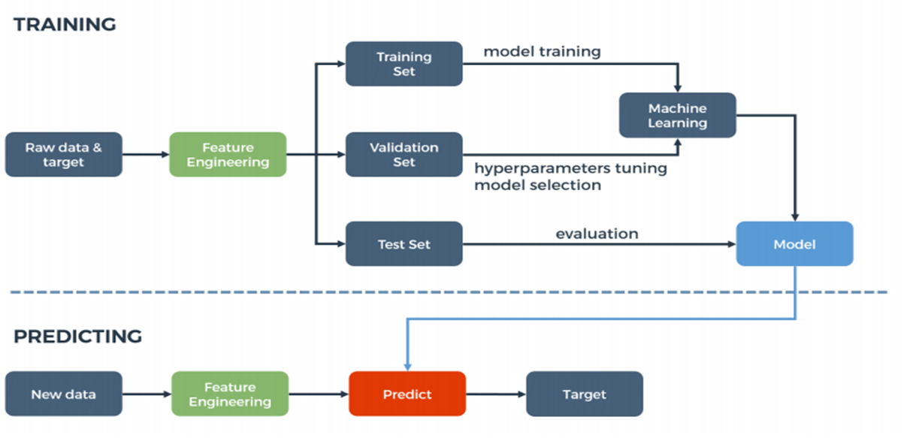

* **HARDWARE/SOFTWARE DESIGN:**

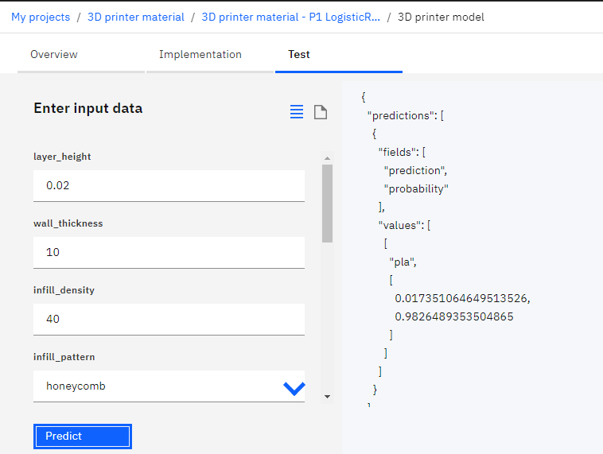

* 1. **EXPERIMENTAL INVESTIGATIONS:**

        1.Collection of data set from Kaggle.

 2.On IBM Watson studio machine learning using auto ai build a model to predict 3D printer material.

* first create account on IBM Watson studio.

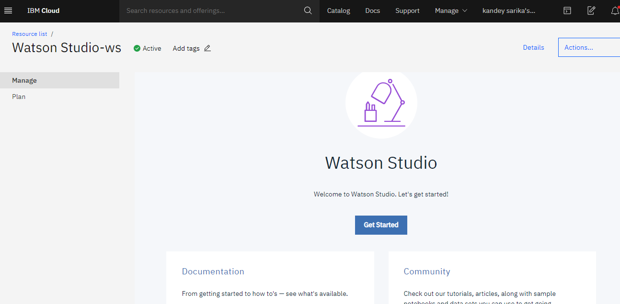

* using  add to project choose auto AI and then upload the data set from kaggle into the data assets.
* deploy the model and test with the various values .



* create a node red app with credentials cloud foundary app.

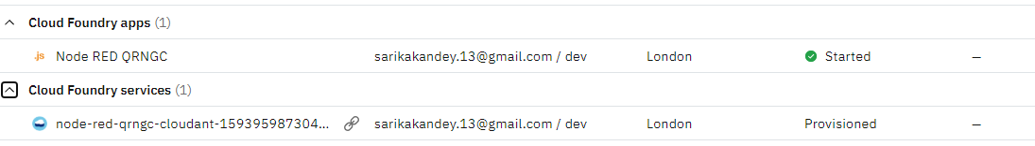

* create a NODE-RED flow to predict values

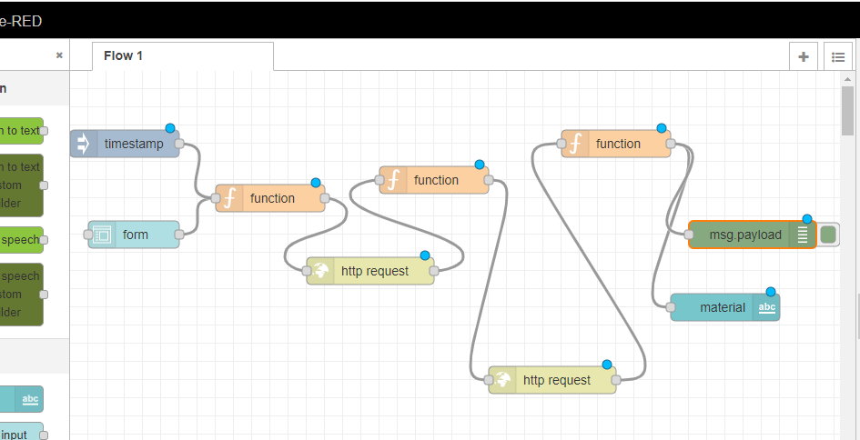

* deploy the flow model and put values in it to predict the model.

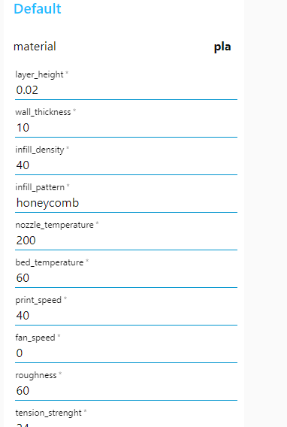

* + 1. FLOWCHART:

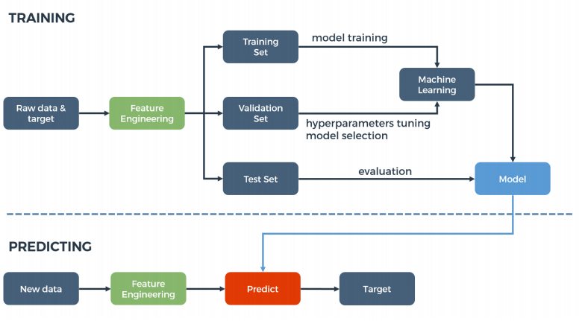

* + 1. RESULT:

The 3D printer material prediction using Watson Auto AI with the help of machine learning to predict the best material to be used for building the 3D models and the model could be ABS Or PLA.



**7.ADVANTAGES:**

Flexible Design  3D printing allows for the design and print of more complex designs than traditional manufacturing processes.Print on Demand  Print on demand is another advantage as it doesn’t need a lot of space to stock inventory, unlike traditional manufacturing processes.

**DISADVANTAGES:**

Limited Materials  While 3D Printing can create items in a selection of plastics and metals the available selection of raw materials is not exhaustive. This is due to the fact that not all metals or plastics can be temperature controlled enough to allow 3D printing. In addition, many of these printable materials cannot be recycled and very few are food safe and many more like Restricted Build Size  ,large volumes and copyright issues.

8.APPLICATIONS:

ABS Acrylonitrile Butadiene Styrene is the plastic used in Legos. It’s tough, nontoxic and retains colour well. It is also easily shaped as it melts; it becomes pliable at about 220 degrees C (430 F). PLA Polylactic Acid is a polymer plastic made from biological materials such as cornstarch or sugarcane. It is similar to the material used in biodegradable plastic packaging. It melts between 180 - 200 degrees C.PVA Polyvinyl Alcohol is a newer class of 3D printing material used for making supports that hold 3D prints in place. It is a synthetic polymer and is water soluble. There are many more applications like HDPE,PET and PETG.

9. CONCLUSION:

              Here by I conclude learned how to use IBM Watson and juypeter anaconda is very easy to access and understand and I gained knowledge and skills in the project this internship is very use full and using bootcamps were help full in the completion of the project.

This project helps to predict best 3D printer material. The internship was also good to find out what my strengths and weaknesses. This helped me to define what skills and knowledge I have to improve in the coming time.

10. FUTURE SCOPE:

                  3D printing will become a mainstream technology for serial production  3D printing has long passed the point of being viewed only as a prototyping solution.Everyday, companies are finding new ways to incorporate the technology into their production, with applications ranging from tooling to spare/replacement parts and some end-use components.

Design software for additive will become more integrated and easier to use  Designing for additive manufacturing is a challenging process, not least because it can be counterintuitive for engineers that have been trained to design for traditional manufacturing

Focusing on education will enable more 3D printing applications and adoption  While adopting 3D printing for prototyping is relatively straightforward, establishing 3D printing for production can be challenging. Not only is investment in hardware required, but companies must also commit the time to develop the expertise needed.

 11.BIBLOGRAPHY:

☆ Kaggle for downloading the dataset.

☆ Smartbridge bootcamp to learn how to work on IBM Watson studio